**Hospital Management System**

1. **Introduction**

The Hospital Management System is a comprehensive solution designed to streamline and manage the administrative, financial, and medical operations of a healthcare facility. This project is developed with the goal of enhancing the efficiency of hospital management processes by automating routine tasks, improving data accuracy, and enabling better coordination between different departments. The system caters to the needs of various stakeholders, including administrators, doctors, and patients, by providing an integrated platform for handling patient information, appointments, staff schedules, and more.

**1.1 Purpose**

The primary purpose of the Hospital Management System is to provide a robust and user-friendly platform that simplifies the complex processes involved in managing a hospital. By automating key functions such as patient registration, appointment scheduling, medical record maintenance, and billing, the system aims to reduce the workload on hospital staff, minimize errors, and improve the overall quality of patient care. Additionally, the system provides real-time access to information, enabling healthcare providers to make informed decisions promptly.

**1.2 Scope**

The scope of the Hospital Management System includes the following key functionalities:

1. **User Management:**
   * Admin: Responsible for managing users, including doctors and patients, as well as importing user data from external files.
   * Doctors: Able to view their schedules, manage appointments, and access patient information.
   * Patients: Can book, view, and cancel appointments, as well as view their medical history.
2. **Appointment Management:**
   * Allows patients to book appointments with doctors based on their availability.
   * Enables doctors to view and manage their daily schedules.
   * Provides functionality for cancelling appointments when necessary.
3. **Medical Record Management:**
   * Maintains detailed records of patients, including medical history, allergies, and treatment plans.
   * Ensures that doctors have access to accurate and up-to-date patient information.
4. **File Importing:**
   * Admins can import user data from external JSON or XML files, allowing for quick and efficient data entry.
5. **User Authentication:**
   * Secure login functionality for all users, ensuring that only authorized personnel can access sensitive information.
6. **Real-time Notifications:**
   * Provides alerts and notifications to users for important actions, such as successful appointment bookings or cancellations.
7. **System Overview**

The Hospital Management System is designed with a modular and scalable architecture, ensuring that it can effectively handle the diverse and complex needs of a modern healthcare facility. The system's architecture is built to provide a seamless flow of information across various departments, enabling efficient management of hospital operations.

**2.1 System Architecture**

The system architecture of the Hospital Management System follows a layered approach, comprising the following key layers:

1. **Presentation Layer (Frontend):**
   * This layer is responsible for the user interface and user experience. It is designed to be intuitive and user-friendly, providing different views and functionalities tailored to the specific needs of administrators, doctors, and patients. Technologies such as HTML, CSS, and JavaScript are used to create responsive and accessible web interfaces.
2. **Application Layer (Backend):**
   * The core logic of the system resides in the application layer. This layer processes user requests, performs business logic, and interacts with the data layer to retrieve or update information. It is developed using Java and Servlets, ensuring robust and secure handling of operations like user authentication, appointment management, and data import/export.
3. **Data Layer (Database):**
   * The data layer is responsible for storing and managing the system's data. This includes patient records, appointment schedules, user credentials, and more. The database is designed to be normalized, ensuring data integrity and minimizing redundancy. SQL-based relational databases are used to handle structured data efficiently.
4. **Integration Layer (APIs & Services):**
   * The system provides APIs and services for integrating with external systems, such as other hospital software or third-party applications. This layer enables data exchange and interoperability, allowing the hospital to maintain a connected ecosystem.
5. **Security Layer:**
   * Security is a critical aspect of the Hospital Management System. This layer implements various security mechanisms, including encryption, secure login, role-based access control, and data validation, to protect sensitive information and ensure compliance with healthcare regulations.
   1. **System Design**

Figure2.2.1 – CLASS DIAGRAM

Figure2.2.2 – ER DIAGRAM

Figure2.2.3 – DATAFLOW DIAGRAM

Figure2.2.4 – USECASE DIAGRAM

**2.3 Key Modules**

The Hospital Management System is composed of several key modules, each serving a specific function within the system:

1. **User Management Module:**
   * **Admin Management:** Enables administrators to manage user accounts, including adding, editing, and deleting users. It also provides functionality for importing users from external files (JSON/XML).
   * **Doctor Management:** Allows doctors to manage their profiles, view schedules, and access patient information.
   * **Patient Management:** Provides patients with the ability to register, log in, and manage their personal information.
2. **Appointment Management Module:**
   * **Appointment Booking:** Facilitates the booking of appointments by patients, allowing them to choose a preferred doctor and time slot.
   * **Schedule Management:** Enables doctors to view and manage their appointment schedules, ensuring efficient time management.
   * **Appointment Cancellation:** Allows patients and doctors to cancel appointments when necessary, with real-time updates reflected in the system.
3. **Medical Records Module:**
   * **Patient Records:** Stores detailed patient information, including medical history, allergies, treatment plans, and contact details. This module ensures that doctors have access to accurate and up-to-date patient data.
   * **Record Access:** Provides controlled access to medical records based on user roles, ensuring that only authorized personnel can view or modify sensitive information.
4. **File Import Module:**
   * **User Data Import:** Allows administrators to import user data from external files, streamlining the process of adding multiple users at once.
   * **Data Validation:** Ensures that imported data is accurate and consistent with the system's data structure, preventing errors and maintaining data integrity.
5. **Authentication & Authorization Module:**
   * **Login/Logout:** Provides secure login and logout functionality for all users, ensuring that access to the system is restricted to authorized personnel.
   * **Role-Based Access Control (RBAC):** Assigns specific permissions to users based on their roles (Admin, Doctor, Patient), ensuring that each user has access only to the functionalities relevant to their role.
6. **Notification & Alerts Module:**
   * **Real-time Notifications:** Sends alerts and notifications to users regarding important actions, such as successful appointment bookings, cancellations, or system updates.
   * **Custom Alerts:** Allows users to set up custom notifications for specific events or conditions, enhancing user engagement and responsiveness.

**3. Functional Requirements**

The Hospital Management System is designed to cover a wide range of functionalities to support the efficient operation of a healthcare facility. Below is a list of the main functionalities of the system:

**1. User Management**

* **Admin Account Management:**
  + Add new users (Admins, Doctors, Patients) to the system.
  + Edit existing user details, including role assignment.
  + Delete users from the system.
  + Import user data from external files (JSON/XML).
  + Manage user access and permissions based on roles (Admin, Doctor, Patient).
* **Doctor Account Management:**
  + View and update personal profile details.
  + Manage daily schedules and availability.
  + Access patient medical records and history.
  + View and respond to appointment requests.
  + Cancel or reschedule appointments.
* **Patient Account Management:**
  + Register and create a new patient account.
  + Login and update personal profile details.
  + View medical history and treatment records.
  + Book, view, and cancel appointments with doctors.
  + Receive notifications about appointment status and medical updates.

**2. Appointment Management**

* **Booking Appointments:**
  + Allow patients to book appointments with available doctors.
  + Provide a calendar view to select preferred dates and times.
  + Enable patients to choose a doctor based on department or specialization.
  + Verify and confirm appointment bookings with real-time feedback.
* **Viewing Appointments:**
  + Allow patients to view their upcoming and past appointments.
  + Provide doctors with a daily, weekly, or monthly view of their scheduled appointments.
  + Display appointment details, including patient information and reason for visit.
* **Cancelling Appointments:**
  + Enable patients and doctors to cancel appointments with appropriate notifications.
  + Provide reasons for cancellation if required.
  + Automatically update the availability of doctors based on cancellations.

**3. Medical Record Management**

* **Patient Medical History:**
  + Store and manage comprehensive medical records for each patient.
  + Include details such as past diagnoses, treatments, allergies, and ongoing medications.
  + Allow doctors to update medical records after consultations or treatments.
* **Access Control:**
  + Ensure that only authorized personnel (doctors and specific admins) can access sensitive medical information.
  + Log all access and modifications to patient records for auditing purposes.

**4. File Import and Export**

* **Importing User Data:**
  + Allow admins to import user data (patients, doctors) from external files
  + Validate the imported data against system requirements before adding it to the database.
  + Provide error handling and reporting for failed imports.
* **Exporting Data:**
  + Enable the export of patient records, appointment schedules, and user details for reporting and backup purposes.
  + Support exporting data in various formats

**5. Authentication and Authorization**

* **User Authentication:**
  + Provide a secure login mechanism for all users (Admins, Doctors, Patients).
  + Implement session management to track user activity.
  + Provide password recovery and reset options.
* **Role-Based Access Control (RBAC):**
  + Assign specific roles (Admin, Doctor, Patient) to users with predefined permissions.
  + Ensure that users can only access functionalities relevant to their roles.

**6. Notifications and Alerts**

* **Real-time Notifications:**
  + Send notifications to patients and doctors about appointment confirmations, cancellations, and reminders.
  + Notify users of important updates, such as changes to schedules or system maintenance.
* **Custom Alerts:**
  + Allow users to set up custom alerts for specific events (e.g., new messages, follow-up reminders).
  + Provide notifications through multiple channels, including email and SMS.

**7. System Administration**

* **System Monitoring:**
  + Provide tools for admins to monitor system performance, user activity, and data integrity.
  + Implement logging and error tracking mechanisms for diagnosing issues.
* **Backup and Recovery:**
  + Allow for regular backups of the system database to prevent data loss.
  + Provide recovery options to restore data in case of system failure.
* **System Configuration:**
  + Enable configuration of system settings, such as user roles, permissions, and notification preferences.
  + Allow customization of the user interface to match the hospital’s branding.

**4. Non-Functional Requirements**

Non-functional requirements define the system's operational qualities and constraints that influence its design, implementation, and performance. These requirements ensure that the Hospital Management System is reliable, efficient, secure, and user-friendly.

**1. Performance Requirements**

* **Response Time:**
  + The system should respond to user inputs within 2 seconds for most operations (e.g., booking appointments, viewing schedules).
  + For data-intensive operations, such as importing large user files, the system should complete the task within a maximum of 10 seconds.
* **Scalability:**
  + The system should be able to handle a growing number of users, records, and transactions without a decrease in performance.
  + It should support a minimum of 500 concurrent users without significant degradation in response times.
* **Throughput:**
  + The system should be capable of processing at least 100 transactions per second, including appointment bookings, cancellations, and user authentications.

**2. Reliability Requirements**

* **Availability:**
  + The system should have an uptime of 99.9%, ensuring it is available for use 24/7.
  + Scheduled maintenance windows should be minimal and communicated in advance to users.
* **Data Integrity:**
  + The system must ensure data consistency and integrity across all operations. Any update to patient records, appointment details, or user data should be accurately reflected in the system without errors.
* **Fault Tolerance:**
  + The system should be resilient to faults and capable of recovering from failures without data loss. In case of system failure, automatic failover mechanisms should be in place.

**3. Security Requirements**

* **Data Privacy:**
  + The system must comply with healthcare data privacy regulations, such as HIPAA (Health Insurance Portability and Accountability Act) in the U.S., ensuring that patient data is securely stored and transmitted.
* **Authentication and Authorization:**
  + The system should implement robust authentication mechanisms, including password protection and session management, to prevent unauthorized access.
  + Role-based access control (RBAC) must be enforced to restrict access to sensitive data based on user roles.
* **Data Encryption:**
  + All sensitive data, including patient records, user credentials, and communications, should be encrypted both at rest and in transit using industry-standard encryption protocols (e.g., AES-256, TLS).

**4. Usability Requirements**

* **User Interface:**
  + The system should have an intuitive and user-friendly interface that can be easily navigated by users with varying levels of technical expertise.
  + The design should follow accessibility standards, such as WCAG (Web Content Accessibility Guidelines), to accommodate users with disabilities.
* **Error Handling:**
  + The system should provide clear and informative error messages, guiding users on how to resolve issues.
  + Input validation should be implemented to prevent incorrect or incomplete data submission.
* **Localization:**
  + The system should support multiple languages to accommodate users from different regions, with the ability to easily switch between languages.

**5. Maintainability Requirements**

* **Modularity:**
  + The system should be designed with a modular architecture, allowing individual components to be updated or replaced without affecting the entire system.
* **Code Quality:**
  + The codebase should follow standard coding practices and be well-documented to ensure ease of maintenance and future development.
* **Documentation:**
  + Comprehensive documentation should be provided, including system architecture, API references, user manuals, and troubleshooting guides.

**6. Portability Requirements**

* **Platform Independence:**
  + The system should be platform-independent, capable of running on different operating systems (e.g., Windows, Linux, macOS) without modification.
* **Browser Compatibility:**
  + The system should be compatible with all major web browsers (e.g., Chrome, Firefox, Safari, Edge), ensuring a consistent experience across platforms.
* **Mobile Compatibility:**
  + The system should be responsive and accessible on mobile devices, providing full functionality on smartphones and tablets.

**6. User Interface Design**

The User Interface (UI) design of the Hospital Management System is centered around providing an intuitive, user-friendly, and accessible experience for all users. The design focuses on clarity, ease of navigation, and ensuring that users can perform their tasks efficiently, whether they are administrators, doctors, or patients.

**1. Design Principles**

The UI design is guided by the following principles:

* **Simplicity:** The interface should be straightforward, with a minimalistic design that avoids unnecessary complexity. Each screen should focus on the primary task at hand, reducing cognitive load on the user.
* **Consistency:** Consistent use of colors, fonts, and layouts across the system helps users to easily learn and navigate the interface. Consistent placement of navigation elements, buttons, and forms ensures a smooth user experience.
* **Accessibility:** The interface should be designed to be accessible to all users, including those with disabilities. This includes considerations for color contrast, font size, and keyboard navigation, ensuring compliance with WCAG (Web Content Accessibility Guidelines).
* **Responsiveness:** The UI should be responsive, adapting to different screen sizes and devices. This ensures that users can access the system on desktops, tablets, and mobile devices without losing functionality or ease of use.
* **Feedback:** The system should provide immediate feedback for user actions, such as form submissions, button clicks, or data validation errors. This helps users understand the results of their actions and guides them through the process.

**2. Main Screens and Layouts**

The Hospital Management System includes several key screens, each designed to cater to specific user roles and tasks.

**1 Login Screen**

* **Purpose:** Allows users (Admins, Doctors, Patients) to securely log in to the system.
* **Elements:**
  + **Username/Email Field:** For entering the user's unique identifier.
  + **Password Field:** For entering the user's password, with an option to show/hide the password.
  + **Login Button:** Submits the login credentials for authentication.
  + **Forgot Password Link:** Provides an option to reset the password if forgotten.

**2 Admin Dashboard**

* **Purpose:** Central hub for administrators to manage the system, users, and hospital operations.
* **Elements:**
  + **Navigation Menu:** Provides links to different sections such as User Management, Appointment Management, and System Settings.
  + **User Management Panel:** Allows admins to add, edit, delete, and import users.
  + **System Monitoring Widgets:** Displays real-time data on system usage, active sessions, and recent activities.
  + **Notifications Section:** Displays important alerts and system messages for the admin.

**3 Doctor Dashboard**

* **Purpose:** Allows doctors to manage their schedules, view patient information, and handle appointments.
* **Elements:**
  + **Schedule Overview:** Displays the doctor's daily, weekly, or monthly schedule with a calendar view.
  + **Appointment List:** Shows upcoming and past appointments with details such as patient name, time, and status.
  + **Patient Information Access:** Allows doctors to view detailed medical records for patients they are scheduled to see.
  + **Notifications:** Alerts the doctor to new appointments, cancellations, and important patient updates.

**4 Patient Dashboard**

* **Purpose:** Enables patients to manage their appointments, view medical history, and update personal information.
* **Elements:**
  + **Appointment Booking Form:** Allows patients to book new appointments by selecting a doctor, date, and time.
  + **Upcoming Appointments:** Lists upcoming appointments with details and options to cancel or reschedule.
  + **Medical History:** Provides a view of the patient's medical records, including past diagnoses, treatments, and prescriptions.
  + **Profile Management:** Allows patients to update their contact information and preferences.

**5 Appointment Booking Screen**

* **Purpose:** Facilitates the booking of appointments by patients.
* **Elements:**
  + **Doctor Selection:** Dropdown menu or search field to select a doctor based on specialization or availability.
  + **Calendar View:** Interactive calendar to choose a preferred date and view available time slots.
  + **Time Slot Selection:** List or grid of available time slots for the selected date.
  + **Confirmation Button:** Finalizes the appointment booking and provides feedback to the user.

**6 User Management Screen (Admin)**

* **Purpose:** Allows administrators to manage user accounts and roles within the system.
* **Elements:**
  + **User List:** Displays all users in the system, with filters and search functionality.
  + **Add/Edit User Form:** Form to create new users or update existing user details, including role assignment.
  + **Import Users Button:** Allows the admin to import user data from external files (JSON/XML).
  + **Delete User Option:** Provides a way to remove users from the system with confirmation dialogs.

**3. Style Guide**

The UI design follows a consistent style guide to ensure uniformity across all screens and components:

* **Color Scheme:**
  + **Primary Color:** #007bff (used for buttons, links, and key highlights)
  + **Secondary Color:** #343a40 (used for text and icons)
  + **Background Color:** #f8f9fa (used for page backgrounds)
  + **Accent Color:** #28a745 (used for success messages and confirmations)
  + **Error Color:** #f44336 (used for error messages and alerts)
* **Typography:**
  + **Font Family:** Arial, sans-serif (for all text)
  + **Heading Font Size:** 24px (H1), 22px (H2), 18px (H3)
  + **Body Text Font Size:** 14px
  + **Button Text Font Size:** 16px (bold)
* **Spacing and Layout:**
  + **Padding:** 10px to 20px (for most components)
  + **Margin:** 10px to 20px (between elements)
  + **Border Radius:** 5px to 10px (for buttons, input fields, and cards)
  + **Shadow:** 0 4px 6px rgba(0, 0, 0, 0.1) (used for cards and modals)
* **Icons:**
  + Use of simple, consistent icons from a library like FontAwesome to enhance usability and visual appeal.

**4. Navigation Design**

* **Top Navigation Bar:** Present on all screens, containing links to the main sections of the system (e.g., Dashboard, Profile, Logout).
* **Sidebar Navigation (Admin & Doctor):** Provides quick access to different management functions and settings.
* **Breadcrumb Navigation:** Helps users understand their current location within the system, especially on complex screens.

**5. Accessibility Considerations**

* **Keyboard Navigation:** Ensure that all interactive elements are accessible via keyboard, with clear focus states.
* **Screen Reader Compatibility:** Use ARIA (Accessible Rich Internet Applications) labels and roles to make the interface usable by screen readers.
* **Contrast Ratios:** Maintain sufficient contrast between text and background to ensure readability for users with visual impairments.

**7. Implementation Details**

This section provides an overview of the technologies used and the database design for the Hospital Management System. Additionally, it highlights the functionality and relationships between the database tables to give a clear understanding of how data is managed within the system.

**7.1 Technologies Used**

The Hospital Management System is developed using a combination of modern technologies that ensure robustness, scalability, and ease of maintenance.

**1. Frontend Technologies:**

* **HTML5:** Utilized for structuring the web pages and creating the interface.
* **CSS3:** Used for styling the web pages to ensure a responsive and visually appealing design.
* **JavaScript:** Provides interactivity and dynamic content updates on the client side.

**2. Backend Technologies:**

* **Java:** The primary programming language used for developing the backend logic.
* **Servlets:** Java-based server-side technology used to handle HTTP requests and responses.
* **JSP (JavaServer Pages):** Used for creating dynamic web pages with embedded Java code.

**3. Database Technologies:**

* **MySQL:** A relational database management system used for storing and managing the system’s data.
* **JDBC (Java Database Connectivity):** Used to connect and interact with the MySQL database from the Java application.

**4. Development Tools:**

* **Eclipse/IntelliJ IDEA:** IDEs used for writing, debugging, and managing the Java codebase.
* **Apache Tomcat:** A web server and servlet container used to deploy and run the web application.
* **Git:** Version control system used for tracking changes in the codebase.

**5. Security Tools:**

* **HTTPS/SSL:** Ensures secure data transmission between the client and server by encrypting communications.

**7.2 Database Design**

The database design for the Hospital Management System involves several key tables that store various types of data, including user information, doctor schedules, patient records, and appointments. The relationships between these tables ensure that data is properly linked and managed within the system.

**Tables Overview**

1. **Users Table**

The users table serves as a central repository for all users within the Hospital Management System, including administrators, doctors, and patients. This table manages authentication credentials and user roles, ensuring that each user has the appropriate access level to perform their tasks.

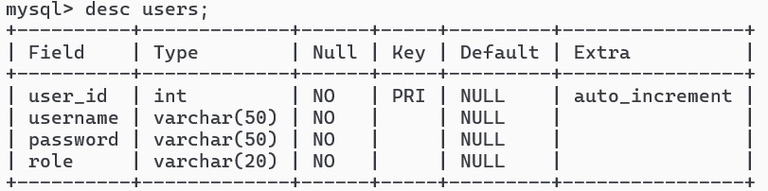

1. **Doctors Table**

The doctors table stores detailed information about doctors, including their specialization and schedule. This table is vital for managing the availability of doctors and scheduling appointments with patients.

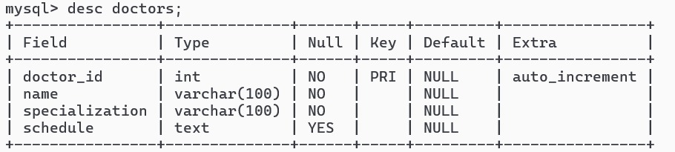

1. **Patients Table**

The patients table holds information about patients who have registered in the hospital system. This table is crucial for managing patient demographics and contact information, which is used during appointments and medical record-keeping.

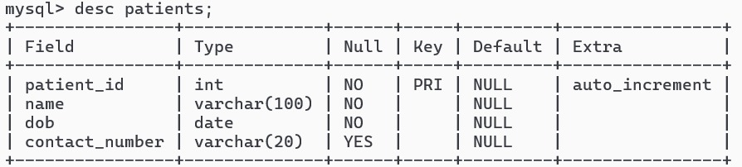

1. **Schedules Table**

The schedules table records the availability of doctors, including the specific dates and times they are available to see patients. This table is essential for the appointment booking system, ensuring that patients can only book appointments during available slots.

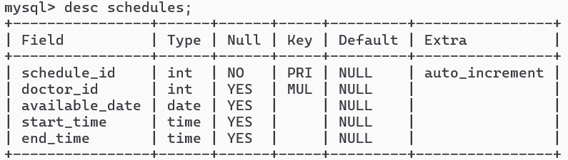

1. **Appointments Table**

The appointments table tracks all scheduled appointments between doctors and patients. This table is central to the hospital management system, as it coordinates the interaction between doctors and patients.

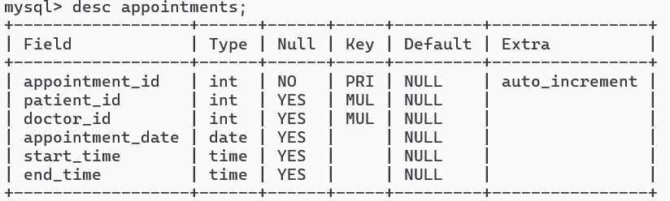

**Relationships Between Tables**

* **Users and Roles:** The users table manages roles through the role column, dictating what the user can do in the system.
* **Doctors and Schedules:** Each doctor has one or more entries in the schedules table that define when they are available for appointments.
* **Doctors and Patients:** The appointments table acts as a junction table linking doctors and patients, recording their interactions through scheduled appointments.
* **Schedules and Appointments:** The schedules table ensures that doctors’ availability aligns with the time slots offered to patients when booking appointments.

**8. Conclusion**

The Hospital Management System is a comprehensive and scalable solution designed to address the complex needs of modern healthcare facilities. By automating key processes such as user management, appointment scheduling, and medical record maintenance, the system significantly enhances operational efficiency, reduces errors, and improves the overall quality of patient care.

Through a user-friendly interface and a robust backend, the system ensures that all stakeholders—administrators, doctors, and patients—can easily access and manage the information they need. The integration of security measures, such as role-based access control and data encryption, ensures that sensitive patient information is protected in compliance with industry standards.

The system's architecture and modular code structure allow for easy maintenance, scalability, and future enhancements, ensuring that it can grow with the needs of the healthcare facility. By adopting the Hospital Management System, healthcare providers can focus more on delivering quality care, while the system handles the administrative and operational complexities.

In conclusion, the Hospital Management System is a vital tool for any healthcare facility seeking to modernize its operations, enhance patient satisfaction, and improve the overall efficiency of its services.